**EAL flash card key rings - £7.50 each**

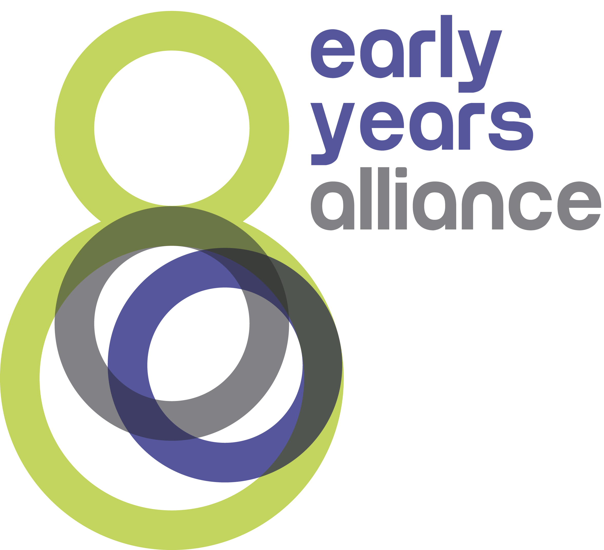

Available to purchase from the EAL Advisory Service

01278 [691719 / eal.service@eyalliance.org.uk](mailto:691719%20/%20southwest@eyalliance.org.uk)

|  |  |  |  |  |  |
| --- | --- | --- | --- | --- | --- |
| **Language** | **Amount** | **Language** | **Amount** | **Language** | **Amount** |
| Albanian |  | Italian |  | Russian |  |
| Arabic |  | Japanese |  | Slovakian |  |
| Bengali |  | Konkani |  | Spanish |  |
| Bulgarian |  | Latvian |  | Tagalog |  |
| Chinese |  | Lithuanian |  | Telugu |  |
| Dutch |  | Malayalam |  | Tetum |  |
| French |  | Polish |  | Thai |  |
| German |  | Portuguese |  | Turkish |  |
| Gujarati |  | Punjabi |  | Urdu |  |
| Hungarian |  | Romanian |  | Ukrainian |  |

Name.........................................................................................................................................

Address......................................................................................................................................

Email..........................................................................................................................................

Each keyring contains a set of 20 words in English, the other language, the pronunciation and a descriptive picture.

The words include: hello, goodbye, please, thank you, yes, no, mummy, daddy, fruit, water, milk, hungry, toilet, play inside, play outside, help, good, sorry, sad and tired.

We will email an invoice to you and will dispatch your order on receipt of payment. Please allow 2 working weeks although we aim to deliver sooner. Items collected directly from us can be paid for on collection.